**RESTAURANT MANAGEMENT SYSTEM**

**Mr. Kamlesh.N.Bari , Mr. Vipul.P.Chavhan , Mr. Tushar.N.Gajbhaye ,**

**Mrs. Simran.M.Gaykar , Mrs. Prachi.V.Jadhav , Mr. Aryan.V.Gampawar**

***Abstract – Since managing a restaurant requires a lot of work, why not have a system that will lessen your workload and simplify daily operations? Restaurants have to handle so many different daily procedures. These can include organizing staff schedules, handling HR, keeping tabs on workers' attendance, processing payroll, and maintaining database and transaction records. Food, restaurants, and their management are highly valued in the market nowadays. The number of eateries and food establishments that are opening up these days is growing daily. It may be regarded as a sign of the quick expansion of the restaurant industry and its management structure. Each restaurant uses a different management system than the others. All hotels and restaurants need to have a management system in place, which is known as a restaurant management system. Some restaurants may be larger than others.***

1. **INTRODUCTION:**

"Food Management Website" is a website that is being developed. The purpose of this system is to automate a restaurant's daily operations. A restaurant is a type of business that provides ready-made food to customers worldwide. This method was created to offer both customers and restaurants service options.

Employees in a restaurant can use this restaurant management system to handle customers, their orders, and to make it simple for them to identify available tables or place orders. Food ordering and reservation table management via an online system, customer and waiter information management, menu information management, and reports are among the services offered. The menu items in the restaurant are arranged into categories: appetizers, soups, salads, entrees, sides, and drinks. The primary goal of the system's construction was to give customers online ordering and reservation services. Every menu item has a name, a cost, and a corresponding recipe.

1. **LITERATURE REVIEW:**

The system used to oversee the restaurant business is the online restaurant management system. The consumer can view the menu page with the items listed in accordance with the requested time after successfully logging in. The primary goal of this system's development was to assist restaurant managers in running their establishments and to facilitate online ordering and table reservations for patrons. The user of the suggested system can look for a menu based on his preferences, such as price range and cuisine category, and then place an order for a meal.

1. **METHODLOGY:**

The main objective of our venture is to increase ordering efficiency while reducing human mistake and offering restaurant patrons high-quality services. The tablet applications ought to be able to communicate with other devices without any problems. The consumer or visitor opens the application and starts the procedure by looking for food products from local locations. By scanning the QR code that is placed on the table, the customer can examine the classified menu card and place an order for food with or without registering or logging in. Selected foods are loaded to the cart, which is available for short-term storage at the hotel.

When a customer chooses to buy, the application determines whether or not his table is active. If it is, the consumer can place an order; if not, the waiter will create a new table. If not, he can pay the billing counter directly and utilize the hotel's dine-out service.

We have developed a database for our project that includes expenses and a list of the daily food items that are required. After completing the login process, the server can use his tablet to search for the table number and place an order for food. The contact details supplied during the login registration process are used to validate the waiter order. After a successful verification, the administrator determines whether or not the waiter confirmed the order. The procedure restarts if not. The administrator sends the order information to the appropriate restaurant if all requirements are met. In the allotted time, the delivery boy finally gives the customer their order. The administrator can make changes to the food menu if they are needed in the database, and the customer's Android smartphone will display the updated menu. This keeps accurate and current information about the menu items while facilitating easy communication and the efficient processing of meal orders.

Customers' dining experiences at restaurants have significantly changed as a result of the deployment of tablet menus. Restaurants can now transfer their menus onto iOS and Android tablets with the help of several tools that already exist. This makes it simpler for patrons to use touch-screen gestures to navigate the menu. By offering an advanced menu display that suggests foods based on a recommendation algorithm, we hope to expand on this idea. Rather than utilizing an expensive iOS tablet, we choose to use an Android-based tablet. Our solution saves money and maintains security by storing the menu database on a cloud-based server. Other developers who have made comparable apps claim that clients seated at tables with tablets typically spend about 10% more than individuals seated at tables devoid of tablets.

This may be explained by the fact that consumers typically make larger purchases when they can place their orders right away and don't have to wait for assistance. Our suggested system is made up of multiple modules that operate in unison to give patrons a distinctive and avant-garde dining experience.

1. **RELATED WORK:**

The rising complexity of restaurant operations and the growing demand for efficiency and customer satisfaction have led to a substantial increase in the attention given to restaurant management systems in recent years. This section reviews the body of research on restaurant management and the systems that are already in use, emphasizing their benefits, features, and contributions to the industry.

**1. Point of Sale (POS) Systems**:

Point of Sale (POS) systems, which include functions like order taking, payment processing, and inventory management, are an essential part of restaurant management. Systems that provide comprehensive solutions suited to different types and sizes of restaurants, such as Square, Toast, and Aloha, have been widely embraced in the industry. By using data analytics, these solutions increase order accuracy, simplify processes, and offer insightful information.

**2. Reservation and Table Management Systems :**

Optimizing seating capacity and improving the dining experience need effective reservation and table management. Customers can reserve tables online using reservation platforms like Resy and OpenTable, and real-time tracking of seating arrangements and table availability is made possible by table management platforms like Rezku and Hostme. The ability to integrate POS systems allows for smooth coordination between walk-ins, reservations, and table turns.

**3. Inventory and Supply Chain Management :**

Cost containment and timely supply of materials and supplies depend on efficient inventory and supply chain management. Recipe costing, vendor management, and inventory tracking are functions offered by systems such as MarketMan and Upserve. These systems assist in minimizing waste and optimizing stock levels by automating inventory procedures and producing purchase orders based on consumption patterns.

**4. Employee Scheduling and Labor Management :**

Optimizing employee schedules and managing labor costs are critical for maintaining operational efficiency and profitability. Platforms such as 7shifts and WhenToWork offer scheduling tools that consider factors like staff availability, labor laws, and forecasted demand. Integration with POS and time tracking systems enables accurate payroll processing and performance analysis, facilitating informed decision-making regarding staffing levels and resource allocation.

**5. Customer Relationship Management (CRM):**

Establishing and maintaining relationships with customers is critical in the cutthroat restaurant business. CRM platforms such as TouchBistro and Upserve offer mechanisms for gathering and organizing client information, overseeing loyalty schemes, and requesting feedback. These technologies contribute to increased consumer satisfaction and repeat business by personalizing marketing efforts and encouraging customer participation.

**6. Mobile Ordering and Delivery Platforms :**

Customers' interactions with restaurants have changed as a result of the widespread use of mobile technology, with an increasing focus on online ordering and delivery options. Mobile ordering systems like ChowNow and Toast TakeOut provide convenient ordering and payment through smartphone apps, while platforms like Grubhub, Uber Eats, and DoorDash offer food delivery from restaurants to clients' doorsteps. Order processing is streamlined and on-time delivery is ensured by integrating with POS and kitchen management systems.

1. **IMPLEMENTATION AND RESULTS**

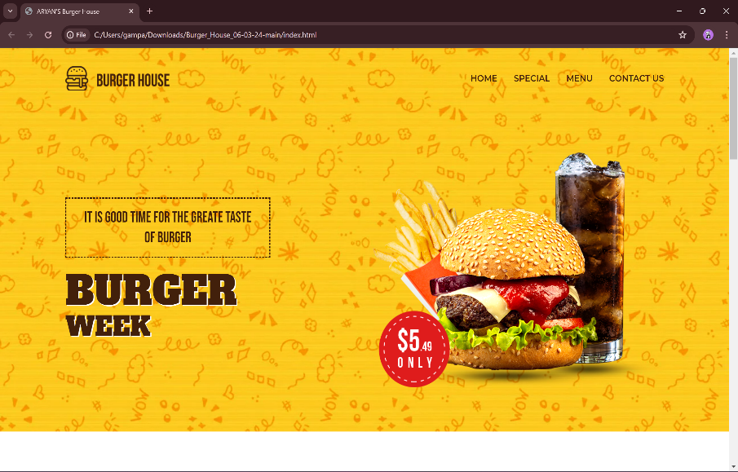For the construction of this project, HTML, CSS, and Javascript were utilized.

This is the website's homepage. It contains four tabs: HOME, SPECIAL, MENU, and CONTACT US. The user can access the homepage by pressing the HOME tab.

The next page will appear after selecting the special tab.

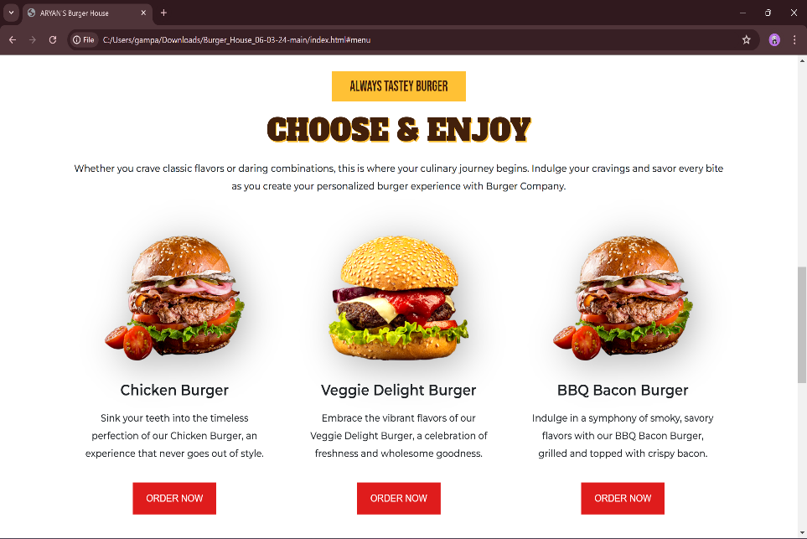

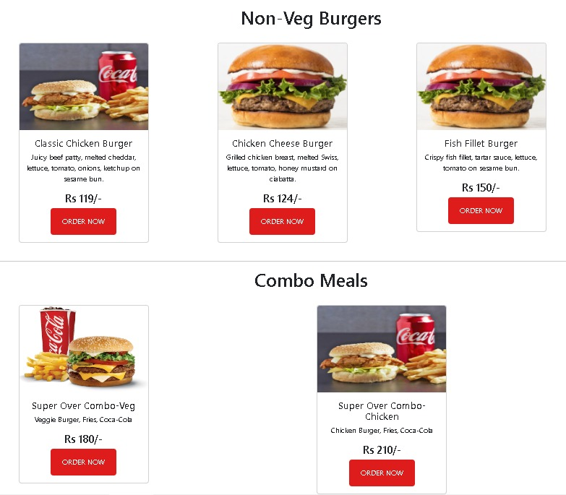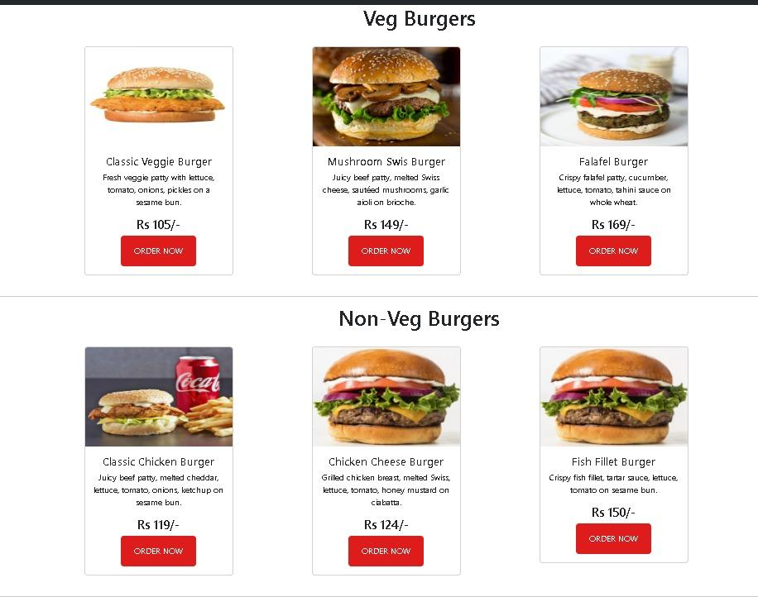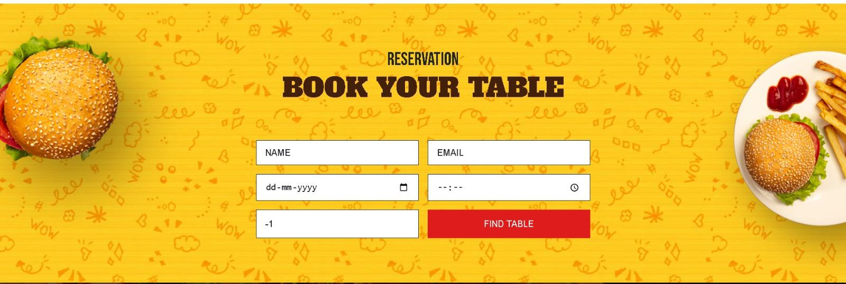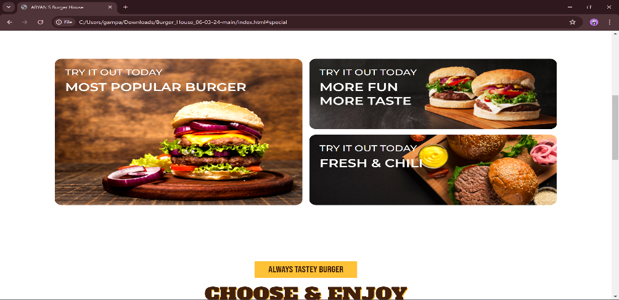 Upon selecting the menu tab, users are presented with an assortment of meal options.

The client can reserve a table by completing this registration form. .

1. **CONCLUSION AND FUTURE SCOPE**

The project's goal was to create a website that would allow users to create a more intuitive menu that they could browse and flick through on a tablet. Additionally, they ordered in order to gather more precise data on the food in a more effective and efficient manner. Information about restaurant inventory can be managed quickly and easily with the use of the restaurant management system. Reports based on sales and profit dates for any desired period are simply obtained by the manager.   
1. Give consumers the option to personalize their meal orders and reservations.   
2. Permit the saving of payment information for later use.   
3. Permits the owner of the restaurant to evaluate the quality of the service and make any required adjustments.   
4. The owner of the restaurant can publish different deals on the tablet.

1. **REFERENCE**
2. Cichy, R.F. & Wise, P. E. (1999). Food and Beverage Service, American Hotel & Lodging Association, Washington, DC.
3. 2.Arnold, K., Gosling, J., & Holmes, D. (2000). The Java Programming Language. AddisonWesley Professional.
4. W.P.S.W. Weerasinghe, K.D.M.I. Jayathilaka, W.V.C. Prasadi, M.D.K.M Goonetilleke, D. I. De Silva, Piyumika Samarasekara.
5. A. Pathak, A. Snghal & B. K. Rana. (2021). Review on hotel management system. 3rd International Conference on Advances in Computing, Communication Control and Networking (ICAC3N), pp. 1834-1837. DOI: 10.1109/ICAC3N53548.2021.9725658.
6. <https://www.coursehero.com/u/file/13388557/CIS-500-Research-paper/>.
7. Google scholar.com